**ASSIGNMENT COVER SHEET**

|  |  |  |
| --- | --- | --- |
| **Student’s name** | Joshua | Morton |
| **Module name** | IT Project Management – QAC020C123S | |
| **Title of assignment** | Baggage Handling System Rebuild Retrospective. | |
| **Complete Word Count in my assignment** | 2720 | |
| **Date submitted** | 19/03/2024 | |

All work must be submitted by the due date. If an extension of time to submit work is required, a [Mitigating Circumstances Extension Form](https://canvas.qa.com/courses/1041/files/660514?module_item_id=143660) must be submitted.



**Has an extension been approved? Yes No If yes, please give the new submission date ….…/..…./…….**

|  |
| --- |
| IMPORTANT: THIS STATEMENT MUST BE READ & SIGNED  **Academic Integrity Statement**  Academic integrity and honesty are fundamental to the academic work you produce at the University of Roehampton. You are expected to complete coursework which is your own and which is referenced appropriately. The university has in place measures to detect academic dishonesty in all its forms. If you are found to be cheating or attempting to gain an unfair advantage over other students in any way, this is considered academic misconduct and you will be penalised accordingly.  **I declare that the work I am submitting is my own work, is properly referenced and has not been submitted elsewhere** |
| **Student Signature (Full Name):**  **Date: 19/03/2024** |

# Table of Contents

Table of Contents 2

Project Identification 3

Stakeholder Analysis 3

Project Ecosystem Map: 3

Stakeholder Power to Interest Matrix 4

Stakeholder Analysis Table 5

Team Building 7

Belbin 7

Shaper 7

Co-ordinator 8

Plant 8

Specialist 8

Project Specifics 9

Scope Statement 9

Work Breakdown Structure 11

Overview 11

Detailed Breakdown 12

Analysis 13

Planning 13

Infrastructure 14

User Interfaces 14

Release Cycle 15

Risk Management 16

Risk Management Process Proposal 16

Risk Breakdown Structure 17

References 19

# Project Identification

This report examines a recent project by a Software Consultancy for an external client in the aviation industry. To maintain the anonymity of stakeholders, consistent aliases will be used instead of real names.

Their client operates a Baggage Handling System (BHS) at Heathrow airport. It required modernizing to allow installation at international airports.

The scope of the project encompassed complex multi-tenancy authentication and authorization policies and migration to cloud infrastructure.

# Stakeholder Analysis

## Project Ecosystem Map:

Figure 1 Project Ecosystem Map - Illustrates how stakeholders within the project interact with each other.

The above diagram illustrates the stakeholders directly involved in the project, establishing a general hierarchy and how communications flow between stakeholders.

## Stakeholder Power to Interest Matrix

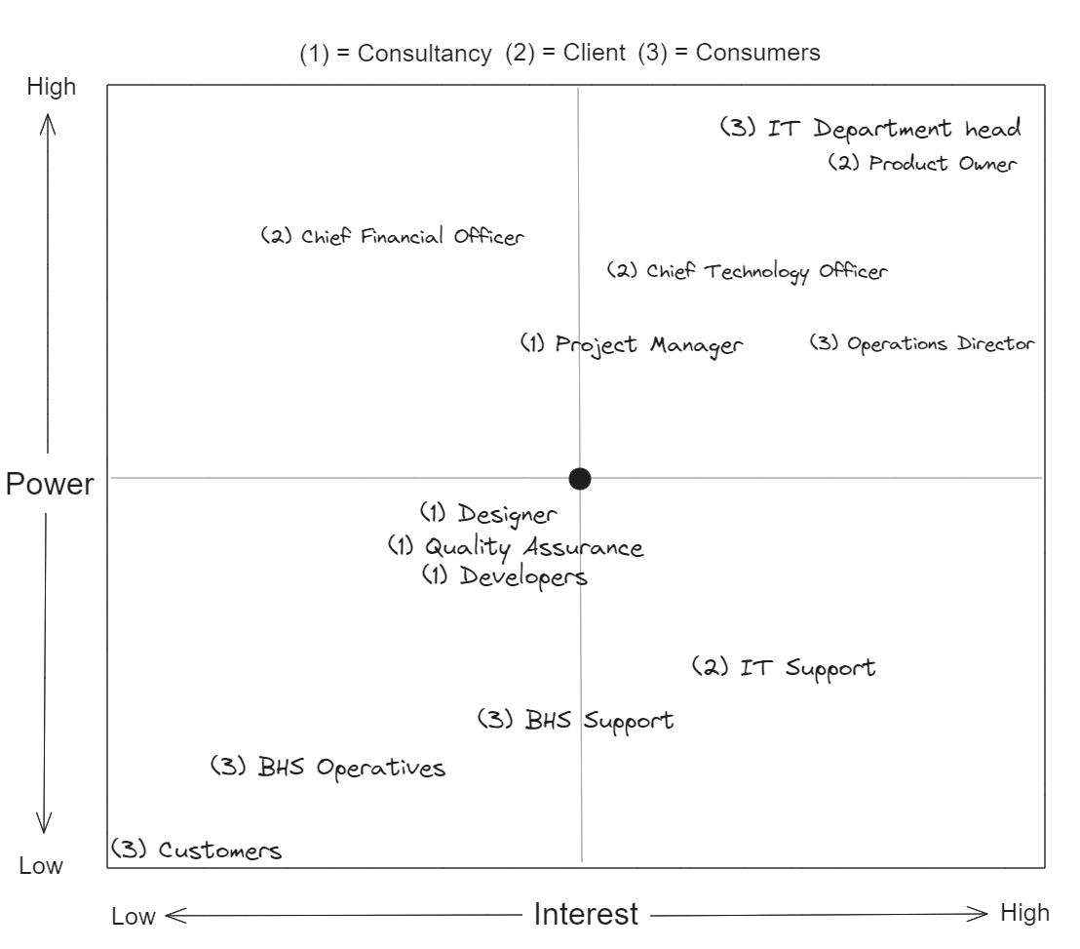

Figure 2 - Stakeholder Power to Interest Matrix

The above diagram demonstrates the level of engagement each stakeholder has with the project. A clear trend has been established, the direct client & consumer (project requester) have a significantly higher power and interest over the project than the consultants who delivered the project.

## Stakeholder Analysis Table

|  |  |  |  |  |  |  |
| --- | --- | --- | --- | --- | --- | --- |
| Stakeholder | Role | Interest | Influence | Potential Impact | Alignment | Engagement Strategy |
| Project Manager (Internal) | Coordination | High (Successful Delivery) | High | Direct and significant | Fully Aligned | Frequent project updates, empowerment in decision making, accountability for project milestones. |
| Developers (Internal) | Implementation | Medium (Career Development) | Medium | Moderate (Quality of work) | Aligned | Inclusion in technical discussions, recognition of contributions. |
| Designer (Internal) | UI/UX Design | High (Design quality and useability) | Medium | High (User Experience) | Aligned | Planning & requirements analysis meetings, involved in user testing, ensure feedback is incorporated. |
| Tester (Internal) | Quality assurance | High (Design quality and useability) | Medium | High (Defect Recovery) | Aligned | Frequent testing cycles, clear bug reporting channels and involvement in reviews. |
| Product Owner (External) | Requirements Analysis | High (Alignment with business needs) | High | Critical (Scope and Features) | Fully Aligned | Regular backlog assessment, scope and requirements analysis, prioritization meetings. |
| Chief Technology Officer (External) | Technical leadership | Very High  (Strategy and implementation) | High | Strategic (Project Direction) | Fully Aligned | Strategic planning sessions, regular project status updates and critical decision-making involvement. |
| Chief Financial Officer (External) | Financial oversight | Medium  (Cost-effectiveness) | Medium | High (Budget adherence) | Aligned | Budget reviews, cost-benefit analysis meetings, financial forecasting. |
| IT Support (External) | Support to end-users. | Medium (Effectiveness of support) | Low | Moderate (User Satisfaction) | Aligned | Ensure system stability and redundancy for end-users, resolve user issues. |
| IT Department head (External Consumer) | Business Adherence | High (Administrative management) | Medium | High (Solving Business use-case) | Aligned | Coordination with IT support, ensure project adheres to business requirement, system administration. |
| Operations Director (External Consumer) | Operational Utilization | High (Process Efficiency) | High | High (Operational Impact) | Fully Aligned | Ensure Operatives and BHS Support are trained to use the system, report new requirements as the system evolves. |
| BHS Support (External Consumer) | End-Users. | Medium (Support & monitoring) | Low to Medium | Moderate (Suggest improvements) | Aligned | Managing incident reports from operatives and ensure data flows through the system. |
| BHS Operatives (External Consumer) | Reporting Events | Low | Low | Low (No interaction) | Unaligned | Communicate physical incidents to BHS Support |
| Airport Customers | Effected by system efficiency | None | None | None | Unaligned | Subconscious interest in system efficiency for overall service satisfaction. |

# Team Building

## Belbin

In the following section, roles of the project delivery team highly engaged stakeholders will be identified. Belbin’s Theory of Team Building (Belbin, n.d) will be employed to categorise individuals into their archetypes.

Figure 3 - Belbin Archetype overview (Morozan, 2013)

Moultrie (2016) argues that a healthy balance of all 9 roles best prepares a project for success, balance was especially challenging throughout this project as these roles were spread across 3 independent organisations.

To allow for an appropriate level of depth, only a few key team members will be discussed. Individuals are discussed based on their measured project involvement. For instance, the Product Owner was more active than IT Department Head, whist they both had the same potential for impact.

## Shaper

Closely matching the description of the Shaper was the external Product Owner.

Being the intermediate between implementers & evaluators, their responsibility was to ensure their clients requirements were met and to identify any areas of improvement their clients hadn’t thought of.

With these goals in mind, their performance is best evaluated by how accurately the final product matched the expectations of their client. From upfront requirements analyses, they identified 12 key features.

Of these features, 3 received change requests after delivery. Arguably, unsatisfactorily shipping 25% of features reflects a poor performance in the requirements analysis stage and a later failure to identify improvements.

This led to the project exceeding the budget by 15%. Despite change requests, the project still managed to be completed within the expected deadline.

They had the challenging role of bridging the gap between multiple organisations; the positive outcomes prove they were instrumental in driving the project forward. However, their abrasive manner often led to conflicts that often-made collaboration challenging.

## Co-ordinator

The Co-ordinator role was fulfilled by the internal Project Manager.

Their role was to ensure the implementers had everything they required to deliver tasks specification and meet timelines as well as drive productivity through team cohesion and morale.

Given their position, they were evaluated based on their team’s velocity, keeping delivery high while minimizing roadblocks. Additionally, on how well they delegated tasks and ensuring individual tasks were clearly defined with acceptance criteria clearly outlined.

In practice, they lead stand-up meetings in a time efficient manner, by breaking features down into small individual tasks that could be easily assigned to the team, while encouraging them to challenge the requirements defined by each task if they weren’t satisfactory. Also, acting as middleware, they protected the implementers from external shareholder pressure, curtailing external risks to delivery, such as scope creep.

Regardless of whether the scope of work directly matched the external clients’ expectations, all work was delivered to the Product Owners expectations and the project deadline was met. It’s clear the Project Manager achieved their goals.

In retrospect, it’s possible they could have invested more time into investigating whether the scope of the project accurately reflected the expected features, by challenging the Product Owner more. Their behaviour throughout the project fits into Tuckman’s “Norming” phase, as they discovered ways to bring multiple departments together.

## Plant

For the Designer, user experience was at the forefront of their responsibilities, they were tasked with collaborating with the end users and developers to provide an intuitive and professional feeling product.

Not only were they measured on how accurately the product matched the client’s brand requirements, but also on the quality of the user stories they produced and how easily their end designs were to implement.

After extensively gathering anecdotes from users of the existing application, they methodically dissected each screen into a plethora of use cases, each with pros and cons. These were translated into designs that reflected the old system, maintaining the pros while reshaping the cons with new ideas. However, the designs produced were often limited with extensibility in mind for the new requirements of the system, adding an additional challenge to the implementers of the system.

Conclusively, they delivered on their goals, but perhaps in practice they acted more as a Specialist, as they became fixated, struggling to consider other roles within the team.

## Specialist

The Specialist, the project’s Senior Developer and Cloud Computing expert acted beyond their role to leverage their skillset. They defined the project’s technical direction.

Driving infrastructure decisions, they were measured on budget optimisation resulting from their cloud configurations and how they could streamline the implementation process for the rest of the team.

Being the only developer with cloud experience, their decisions had the largest observable impact on factors including automated testing & deployment pipelines, and cloud-native service architectures. Their decisions empowered the developers to iterate quickly on features, offloading challenging features to cloud-native services, reducing budget pressures.

They exceeded the expectations of their role in isolation, however, they often clashed with the Project Manager. This tension mirrored the ‘Storming’ phase in Tuckman’s model (WCU, n.d.), emphasizing the need for inclusive decision-making in future projects.

# Project Specifics

## Scope Statement

The following section employs a predictive planning approach to discuss the high-level deliverables up front, a Work Breakdown Structure will later decompose this into a detailed report (PMI 2021, pg.56).

For the sake of brevity, only key elements are outlined.

|  |  |
| --- | --- |
| **Project Name** | **Baggage Handling System Rebuild** |
| **Objectives** | The existing system was built with deprecated technology, resulting in many hurdles to overcome when implementing new features. The primary goal is to rebuild the existing system from the ground-up with extensibility in mind. |
| **Scope Definition** | Primarily, the existing system’s features need to be matched in the new system, encompassing a management website & mobile application, these must be built with proper authentication & authorization.  This will allow proper access control management and asset approval to individual users.  Additionally, cloud-first infrastructure is to be used for cost savings & risk mitigation. |
| **Requirements** | Beyond replicating the existing functionality, a role-based hierarchy needs to be implemented, with a clear separation of capabilities for “Administrators” and “Users”.  Users must be authorized before they can see and interact with assets within the system, Administrators manage both assets and user accounts.  Support for real-time messaging and communication must be added for certain features, such as reporting dashboards.  Finally, a data migration plan must be established to ensure no historical reporting information is lost from the previous system. |
| **Boundaries** | Existing features & new modifications discussed in the Scope Definition & Requirements section are all that will be delivered.  The project team will manage cloud-hosted infrastructure, the on-going expenses will be billed to the client monthly.  The project team will not be involved in the day-to-day administration and management of the system after the go-live date. |
| **Acceptance Criteria** | * Historical data preserved. * Existing features mirrored. * No asset access without explicit approval. * Fault tolerant, auto-scaling infrastructure exceeding 99.9% uptime. * Evidence of stress testing the infrastructure. |
| **Constraints** | Must run in synchrony with existing system for the first 3 months after release, to ensure no disruption to operations.  Production release must be during a quiet period of operations. I.e., not within national holidays or education breaks. |
| **Assumptions** | The scope of the project has been documented and estimated under the assumption that all existing features are evidenced within the code artefacts of the existing system and that the requested features are agreed upon and locked in until post-release.  Exceptions will be made for critical requests with the understanding of additional budget fees and extended development periods. |

## Work Breakdown Structure

### Overview

Figure 4 - WBS Overview

The above figure displays a step-by-step high level breakdown order of progression to ensure the successful completion of the BHS rebuild. Sections sub-labelled imply completion in alphabetical order. For example, section 1a, “Pre Project” must be completed before 1b “Post Signoff”, whereas 4 “Website” & 4 “Mobile App” can occur simultaneously.

Figure 5 - WBS Tree Structure

This work breakdown structure emulates the Waterfall Methodology of Project Management, wherein each step must be completed and flow directly into the next.

## Detailed Breakdown

In this section, each segment will be broken down into much more detailed tasks that must be completed.

Figure 6 - Fully Detailed WBS view.

### Analysis

Figure 7 - WBS Analysis

This stage is required to answer the “what”, “when” and “who” questions. The scope of the project is discovered, stakeholders agree on budgets, timelines and deliverables and the project team is constructed.

### Planning

Figure 8 - WBS Planning

In the planning stage, the “how” and “why” questions are answered. The team discusses what technologies are best to solve the project’s challenges and high-level designs are constructed to outline what is being built.

These serve as guidelines in later implementation stages.

### Infrastructure

Figure 9 - WBS Infrastructure

The foundations of the system are tangentially implemented in this stage. If the project was building a residential domicile, the physical foundations would be constructed here as well as the plumbing works surrounding the building. The cloud hosting infrastructure & services must be built alongside the systems backend to ensure that the business problems can be solved before any interfaces are built.

### User Interfaces

Figure 10 - WBS User Interfaces

Following the foundations, both user interfaces can be implemented in isolation, these will be built following the designs from the earlier stages. This stage should be relatively short as all the business challenges have been solved in the prior stage.

### Release Cycle

Figure 11 - WBS Release Cycle

This is the final stage that covers the acceptance criteria set by the client. Users start to be involved with the system while they can still change the underlying implementations and rigorous testing is conducted to ensure the infrastructure can satisfy the requirements once in full-scale production. Finally, the constraints identified in the Scope Statement are implemented at final live migration.

# Risk Management

## Risk Management Process Proposal

Hillson (2020, pg.5), states that Risk Management Processes (RMP) are techniques used to identify, assess, and manage both opportunities and threats. Within a Software project involving many stakeholders, a structured RMP is essential to mitigate potential risks that can impact the success of the project.

Figure 12 - Risk Management Process (Horvath, 2024)

The above demonstrates a typical five step RMP, note how this is cyclical in nature, as active responses to planned for and encountered risks can help identify previously unknown risks.

Firstly, the project management team, involving internal and external stakeholders, must extensively brainstorm potential risks. These could include hidden technical challenges, resource constraints due to sickness and holiday and most devastatingly, poor requirements analysis and change requests in later project stages.

A graph showing a cost vs.

Figure 13 - Relative Cost (Gause et al. 2011)

This chart illustrates the relative cost of change requests or missed requirements as a software project progresses.

Following identification, each risk must be analysed to determine its likelihood and potential impact. For example, the likelihood of the elected Cloud Service Provider is extremely low, while it’s impact would be catastrophic.

Next, evaluations must be conducted to prioritize risks based on their severity and likelihood and for each risk, a response strategy must be formulated to serve as documented guidelines for the risk. Response strategies can be varied, low-impact risks could potentially be accepted while high-impact risks will need to be mitigated.

Finally, as RMPs are continuous and iterative, the current processes must be reviewed and evaluated at regular intervals, or at major project milestones.

## Risk Breakdown Structure

The below table demonstrates an RBS that closely matches the processes discussed previously.

A risk score is calculated by multiplying the impact by the probability.

This identifies and describes 5 key risks, in practice, over 100 risks were identified with this project.



Figure 14 - Risk Breakdown Structure

# References

Belbin Website. N/D. The Nine Belbin Roles. [Article] Available at: <https://www.belbin.com/about/belbin-team-roles> [Accessed 22/02/2024]

Belbin, R Meredith. 15/01/1996. Team Roles at Work. 1st Edition. Butterworth-Heinemann Ltd, Oxford, United Kingdom. [Accessed 26/02/2024]

Bob Hughes, Roger Ireland et al. 2004. Project Management for IT-Related Projects. Textbook for the ISEB Foundation Certificate in IS project Management. 1st Edition. British Computer Society, Swindon, United Kingdom.

CMI, 2024. Stakeholder Analysis and Management. [Whitepaper] Available at: <https://www.managers.org.uk/wp-content/uploads/2020/03/CHK-234-Stakeholder-analysis-and-management-1.pdf> [Accessed 18/02/2024]

Gause, Donald C et al. 04/02/2011. Exploring Requirements: Quality Before Design. 1st Edition. Dorset House Publishing, Broadway, New York. [Accessed 09/03/2024]

Hillson, David. 03/11/2020. Practical Project Risk Management. 3rd Edition. Kogan Page, London. [Accessed 09/03/2024]

Horvath, Ingrid. 06/03/2024. Five Steps of Risk Management Process. [Article] Available at: <https://www.invensislearning.com/blog/risk-management-process-steps/> [Accessed 09/03/2024]

Project Management Institute (PMI), 01/07/2024. A Guide to the Project Management Body of Knowledge – PMBOK Guide. 7th Edition. Project Management Institute, Pennsylvania, USA.

Morozan, Olga, 26/12/2024. Belbin’s Team Roles. [Presentation] Available at: <https://www.slideshare.net/oli4ka/belbins-team-roles-29502315> [Accessed 26/02/2024]

Moultrie, James. 2016. Belbin’s Team Roles – Institute for Manufacturing, Cambridge University. [Article] Available at: <https://www.ifm.eng.cam.ac.uk/research/dmg/tools-and-techniques/belbins-team-roles/> [Accessed 26/02/2024]

Newton, Richard. 19/08/2026. Project Management, step by step: how to plan and manage. Pearson Education, Boston, USA.

Rene Van Der Hout, 2013. An interview with Dr Meredith Belbin. [Online] Available at: <https://www.youtube.com/watch?v=E95Vw5fbQhU> [Accessed 21/02/2024]

West Chester University (WCU), N.D. ‘Tuckman’s Stages of Group Development’. Available at: <https://www.wcupa.edu/coral/tuckmanStagesGroupDelvelopment.aspx> [Accessed 28/02/2024]